Name: Khushi Nitinkumar Patel

PRN: 2020BTECS00037

Batch: T2

**Assignment No 1**

# ## Use Playgrounds

The code below prints a few short statements about what you have learned so far. Open the console area and view the code's output.

print ("I have learned the following:")

print("What features make Swift a modern and safe language") print("How to use the Swift REPL in Terminal")

print("How to use playgrounds to make writing Swift fun and simple")

1. Now print your own phrases to the console. Pick one of your favorite songs. Use your knowledge of the `print` function to display the song title and artist.

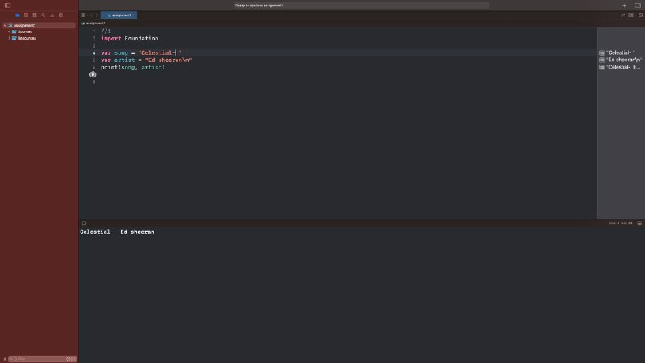

1. Use multiple `print` functions to write out some of the lyrics to the song.

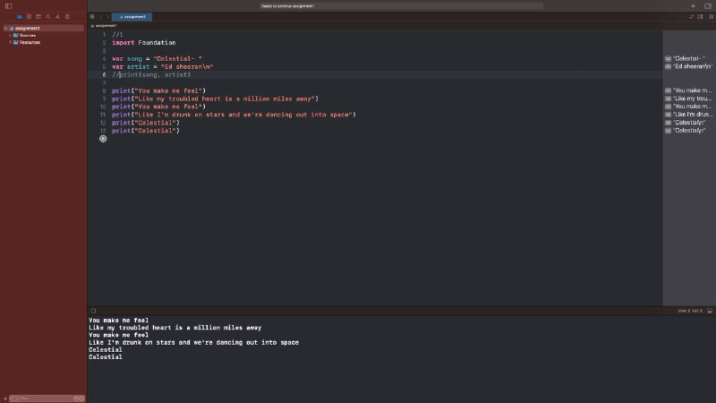

# ## Constants

1. Declare a constant called `friends` to represent the number of friends you have on social media. Give it a value between 50 and 1000. Print out the value by referencing your constant.

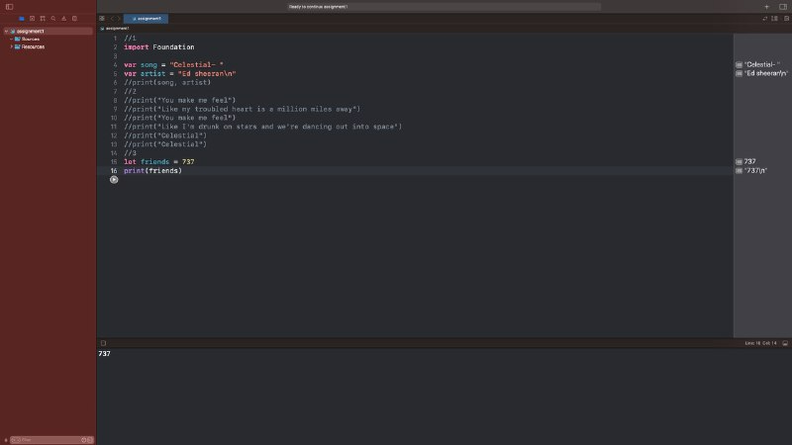

1. Now assume you go through and remove a lot of your friends that aren't active on social media. Update your `friends` constant to a lower number than it currently is between 1 and 900.

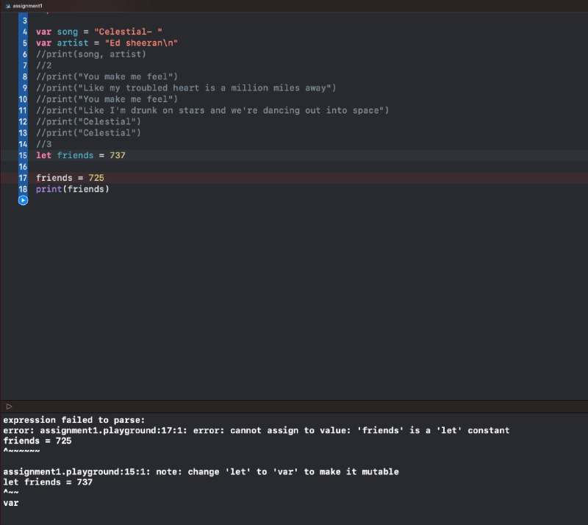

1. Does the above code compile? Why not? Print your explanation to the console using the `print` function. Go back and delete your line of code that updates the `friend` constant to a lower number so that the playground will compile properly.

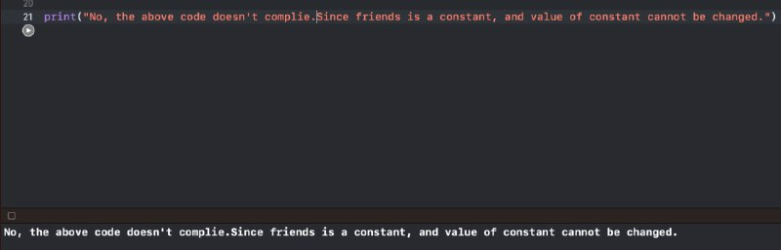

1. Now pretend you just had a birthday, and update the `age` variable accordingly. Print `age` to the console.

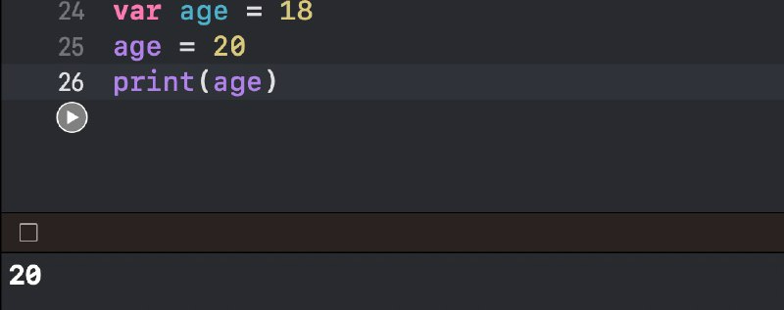

1. Create a double variable with a value of 1.1. Update it to 2.2, 3.3, and 4.4, printing out the value after each assignment (again by referencing the variable you created).

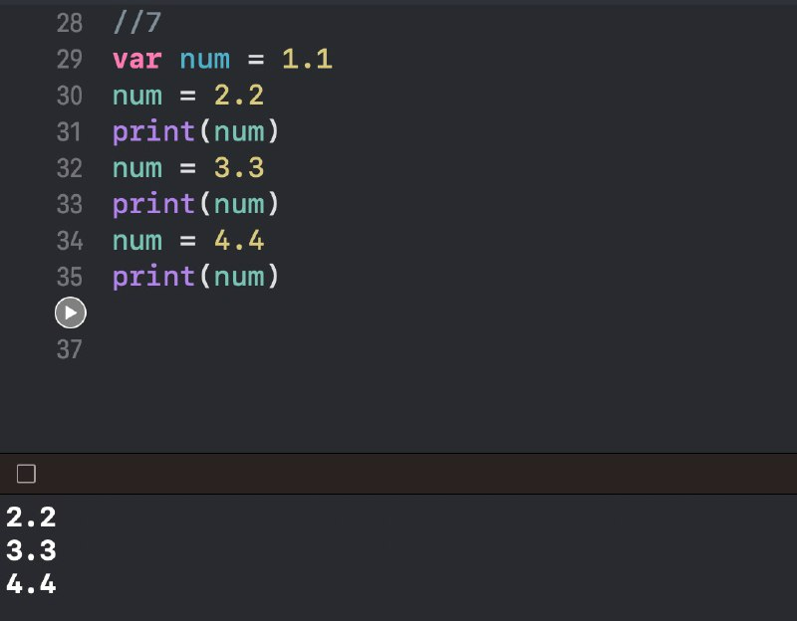

1. Create a boolean variable and set it to `true`. Print the variable, then assign it a value of `false`, and print it again.

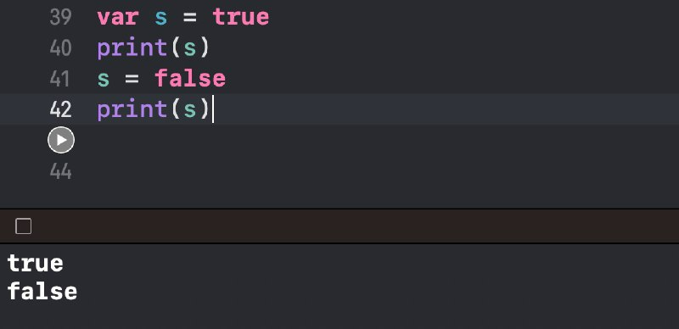

1. Create two variables, one with a value of 0, the other with a value of 0.0. Try to assign the second variable to the first, and you will receive an error. Add the necessary type annotation that will allow the second variable to be assigned to the first.

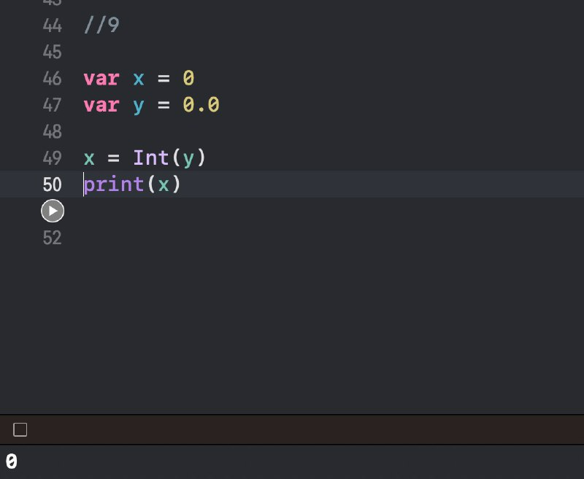

1. Create a variable integer with a value of 1,000,000,000, ensuring that you format it so it is more readable (i.e. it's hard to read 1000000000, so make it easier to read).

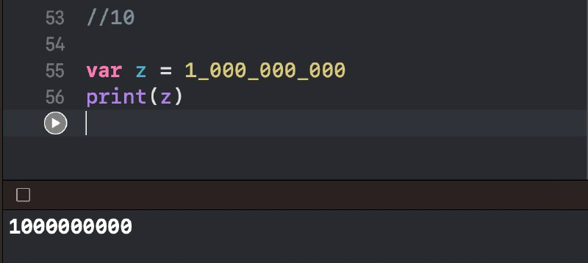

# ## App Exercise - Step Goal

1. Your fitness tracking app needs to know goal number of steps per day. Create a constant

`goalSteps` and set it to 10000.

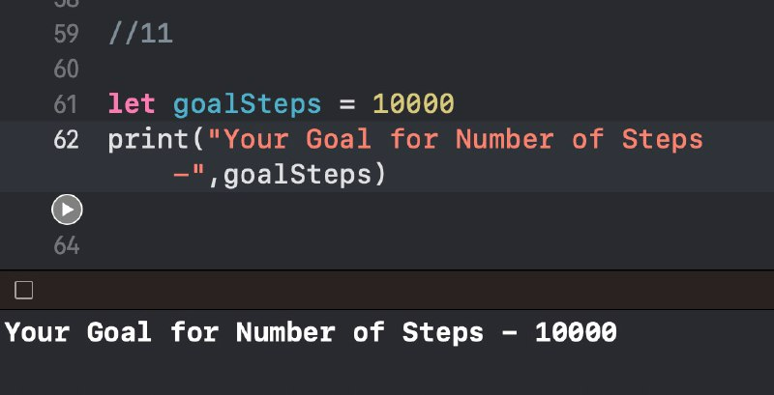

1. Use two `print` functions to print two separate lines to the console. The first line should say "Your step goal for the day is:", and the second line should print the value of `goalSteps` by referencing your constant.

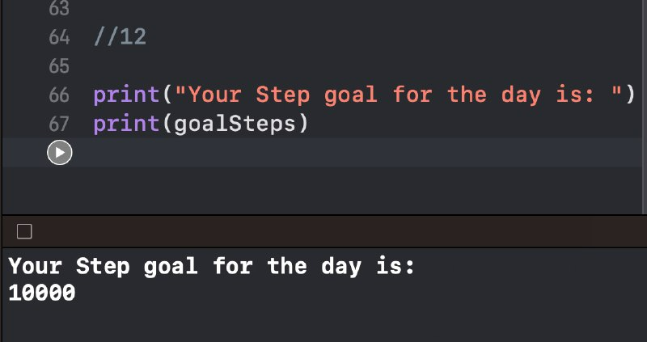

# ## Variables

1. Declare a variable `schooling` and set it to the number of years of school that you have completed. Print `schooling` to the console.

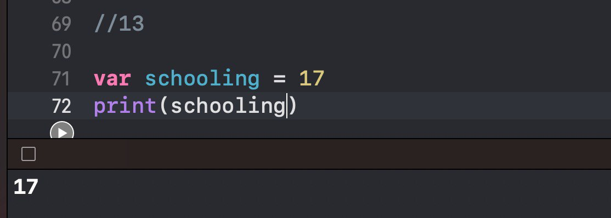

1. Now imagine you just completed an additional year of school, and update the `schooling` variable accordingly. Print `schooling` to the console.

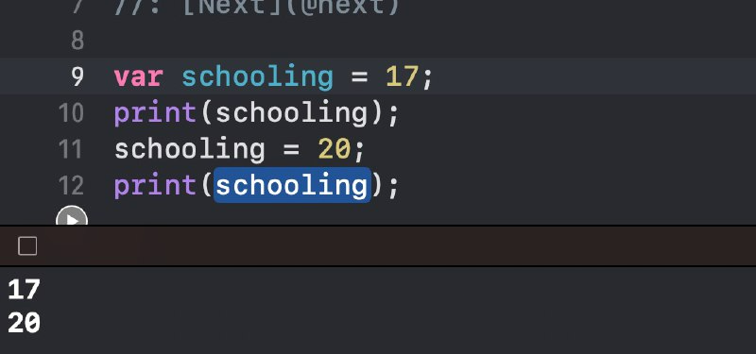

1. Does the above code compile? Why is this different than trying to update a constant? Print your explanation to the console using the `print` function.

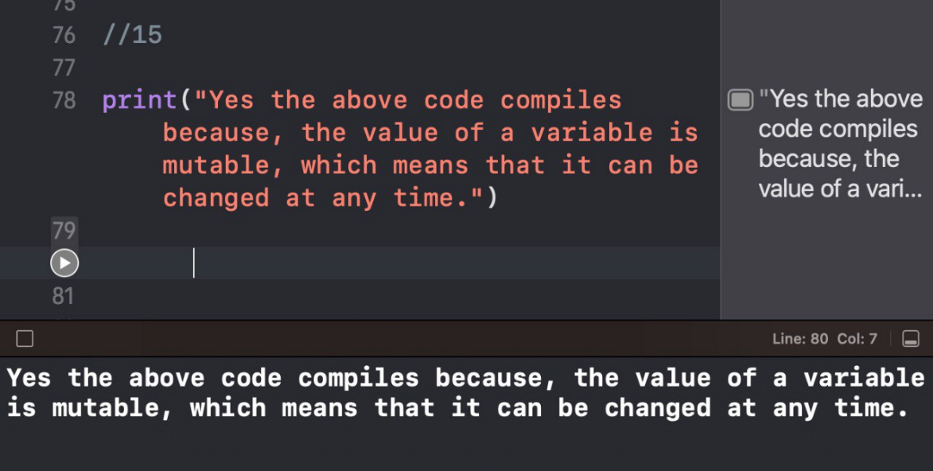

# ##App Exercise - Step Count

1. Create a variable called `steps` that will keep track of the number of steps you take throughout the day. Set its initial value to 0 to represent the step count first thing in the morning. Print `steps` to the console.

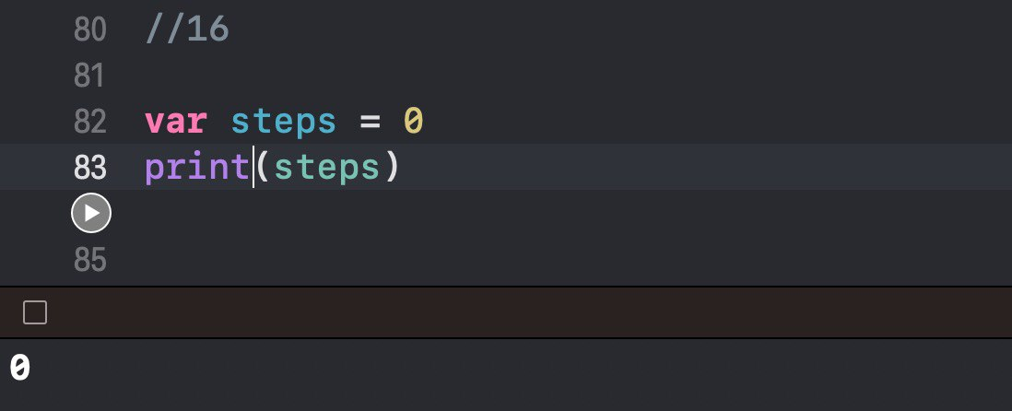

1. Now assume the tracker has been keeping track of steps all morning, and you want to show the user the latest step count. Update `steps` to be 2000. Print `steps` to the console. Then print "Good job! You're well on your way to your daily goal."

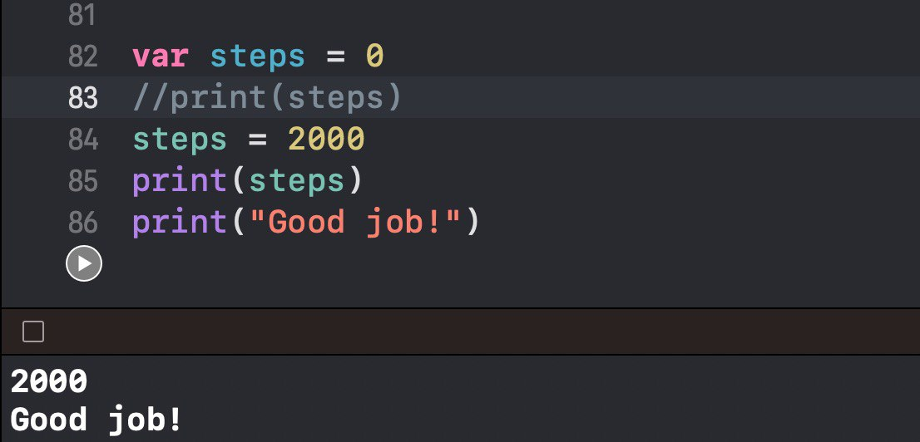

# ## Constant or Variable?

1. Imagine you're creating a simple photo sharing app. You want to keep track of the following metrics for each post:
   * Number of likes: the number of likes that a photo has received
   * Number of comments: the number of comments other users have left on the photo
   * Year created: The year the post was created
   * Month created: The month the post was created represented by a number between 1 and 12
   * Day created: The day of the month the post was created

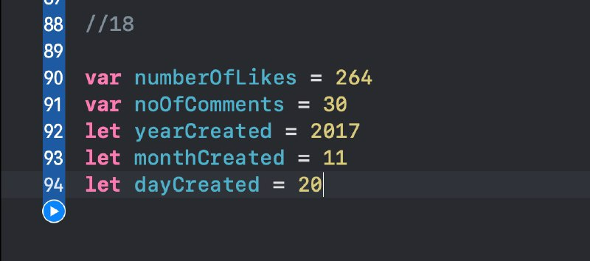

1. For each of the metrics above, declare either a constant or a variable and assign it a value corresponding to a hypothetical post. Be sure to use proper naming conventions.



1. There are all sorts of things that a fitness tracking app needs to keep track of in order to display the right information to the user. Similar to the last exercise, declare either a constant or a variable for each of the following items, and assign each a sensible value. Be sure to use proper naming conventions.
   * Name: The user's name
   * Age: The user's age
   * Number of steps taken today: The number of steps that a user has taken today
   * Goal number of steps: The user's goal for number of steps to take each day
   * Average heart rate: The user's average heart rate over the last 24 hours

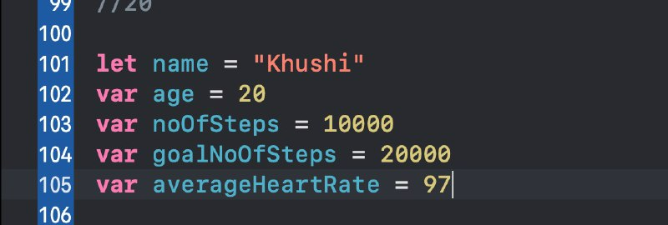

1. Now go back and add a line after each constant or variable declaration. On those lines, print a statement explaining why you chose to declare the piece of information as a constant or variable.



